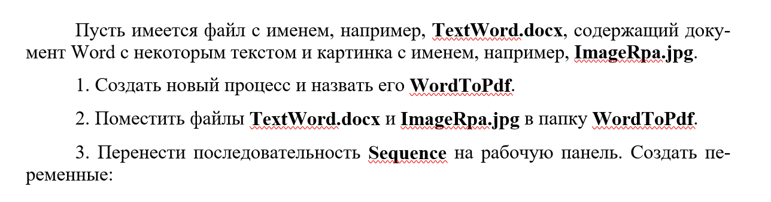

Hi. This is Text Wodr file



Hi. This is Text Wodr file

